Hard Shadow

📘 Definition
# Source: AI Source: Provided by: [Data Path: Persons Table -> ID Column: 1, Name_En Column: Motasem Essam] -> From: [ChatGPT] on [5/2/2026]
A Hard Shadow is a type of shadow that has clear, sharp edges. It forms when a light source is small or very focused, so the shadow looks strong and well-defined.

🌑 How hard shadows form
# Source: AI Source: Provided by: [Data Path: Persons Table -> ID Column: 1, Name_En Column: Motasem Essam] -> From: [ChatGPT] on [5/2/2026]
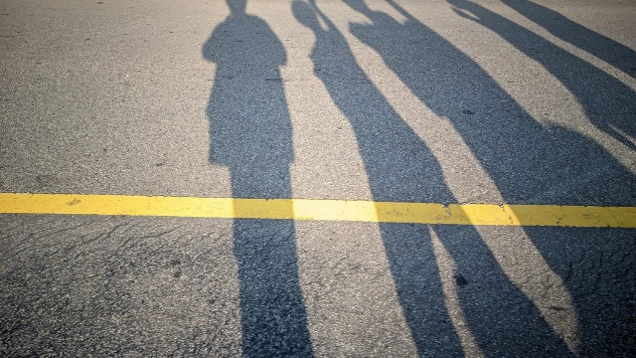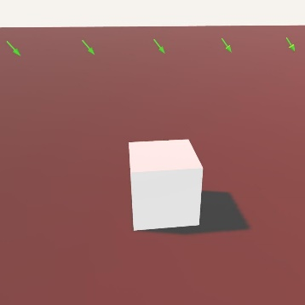
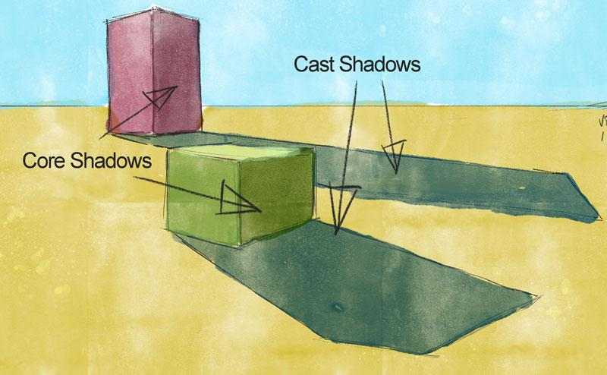
- Light comes from a small or direct source
- Very little light spreads around the edges
- The shadow has a clear boundary

🧠 Simple example
# Source: AI Source: Provided by: [Data Path: Persons Table -> ID Column: 1, Name_En Column: Motasem Essam] -> From: [ChatGPT] on [5/2/2026]
Think of:
- ☀️ Direct sunlight at noon → sharp shadow under your feet
- 🔦 Flashlight in a dark room → strong, clear shadow on the wall

🎮 Where hard shadows are used
# Source: AI Source: Provided by: [Data Path: Persons Table -> ID Column: 1, Name_En Column: Motasem Essam] -> From: [ChatGPT] on [5/2/2026]
- 🎮 Video games (for realistic lighting effects)
- 🎬 Animation and movies
- 🧑‍🎨 3D modeling and rendering
- 🏗️ Architectural visualization

⚙️ Key features
# Source: AI Source: Provided by: [Data Path: Persons Table -> ID Column: 1, Name_En Column: Motasem Essam] -> From: [ChatGPT] on [5/2/2026]
- ✂️ Sharp, clear edges
- 💡 Created by small or direct light sources
- 🎯 High contrast between light and dark areas
- 🌑 More noticeable and dramatic

🚀 In short:
# Source: AI Source: Provided by: [Data Path: Persons Table -> ID Column: 1, Name_En Column: Motasem Essam] -> From: [ChatGPT] on [5/2/2026]
Hard Shadow = a sharp-edged shadow formed by strong, direct light with little scattering.

